

**KULLIYYAH OF INFORMATION AND COMMUNICATION TECHNOLOGY**

**SEM 2 2020/2021**

**INFO 2302**

**WEB TECHNOLOGIES**

**Project Final Report:**

**Travel Voyage in Malaysia**

**Prepared by:  
 Group Name: Group 1**

**Group members:**

|  |  |  |
| --- | --- | --- |
| Name | Matric no. | Email address |
| SIDDIKI HASAN AL BANNA | 1732003 | hasanalbannasiddiki@gmail.com |
| ALWARD MOHAMMED SADEQ AHMED | 1734825 | alsadeqmohammed2020@gmail.com |
| NUR SYAZWANI BINTI JAMALUDIN | 1929958 | wani182437@gmail.com |
| ASYARI SHABIR TAUFIQURRAHMAN | 2019681 | shabirtaufiq.a@gmail.com |

**Prepared for:  
Lecturer: DR. MARINI BINTI OTHMAN  
Section: 3**

1. **Project Description**

The Internet offers a new medium for consumers to acquire useful information and purchase products, information, and services. A travel blog and booking website is an online platform that permits online booking service and history and other information required for a traveller.

Travel Voyage in Malaysia is an online-based website with a wide range of tourist spots collection where the user can get all the information, they need to visit those spots conveniently. This website is mainly focused on top destinations in Malaysia including both Peninsular and East regions. we are expecting the local and the foreigner tourists to visit our website when they want to travel around Malaysia as we highlight the important things on the website such as the history of the tour places and where they are located, some easy ways to find and book a guide by just finding the location to be visited on the Google Map and simply book a car. On top of that, we also provide the contact info and some FAQs for any tourist who seeks help. at our main homepage, we give some previews on some hot promotions to attract the tourists to grab the deals. Lastly, we put the newsletter subscription box for them to drop their email address as well if they are interested in getting the latest updates about the travelling news or promotions.

In order to make connections with the travel agencies, we are teaming up with proven local guides and agencies to provide the best service for our customers. It means that we are trying our best in building a team that cares about the customers and provides all the necessary information about the destinations.

Customers also can book the deals they want to choose for their vacation. After choosing the deal, the customer can check the facilities that we include in our packages. On some occasions such as Eid al-Fitr, and Chinese New Year, some promo codes will be available to be redeemed by the customer to get lower prices.

General information of the company such as our official email address, contact numbers will be listed on the website if there is any enquiry or feedback from the customers. We are glad to assist the customers in the best way we can.

1. **Project Sitemap**

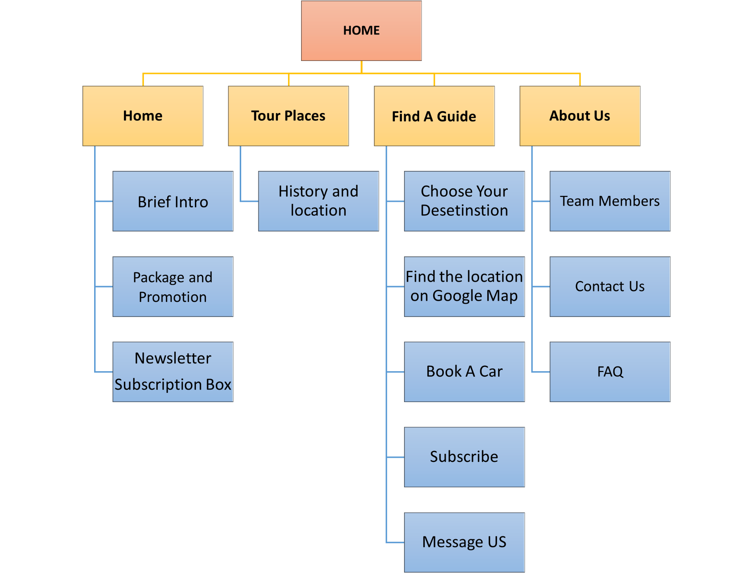

1. **Group Contributions**

|  |  |
| --- | --- |
| **Name** | **Contributions** |
| **Siddiki Hasan Al Banna (1732003)** | * **Find a Guide page (HTML, CSS, JavaScript, API)** * **Booking page (HTML, CSS, JavaScript)** * **Make a useful Navigation bar for every page and added it.** * **Connect and merge all the pages together.** |
| **Asyari Shabir Taufiqurrahman**  **(2019681)** | * **Pages: Destinations, and sub-pages for various destinations.** * **JavaScript: Google Maps API and photo slider for destinations [fotoramaio] .** * **Other: collection and management of appropriate free-to-use images.** |
| **Nur Syazwani binti Jamaludin (1929958)** | * **Pages: Homepage, Packages and Promotions page** * **Web elements: Logo, popup** * **Added 3 deals at Homepage, added 10 deals in Packages and Promotions page with appropriate styling** * **JavaScript event handler for Submit (popup)** |
| **Mohammed Sadeq Ahmed Alward (1734825)** | * **Pages: About Us, Contact Us, and FAQs pages.**   **● Develop the skeleton of the homepage.**  **● Designing the whole page about us (HTML,CSS)**  **● Designing the whole page of Contact us (HTML,CSS)**  **● Designing the whole page of FAQs (JS,HTML,CSS)** |

**4. Use of third-party resources**

|  |  |  |  |
| --- | --- | --- | --- |
| **Web elements** | **Name** | **Use of third party resources and modifications (if any)** | **Modifications (if any)** |
| **Logo** | **Nur Syazwani** | **The logo is created in Canva and is used in all pages to return to the homepage.** |  |
| **API** | **Hasan Al Banna** | **Google Map API has used various time for showing the location.** |  |
| **Graphics** | **All members** | **All graphics for all pages are from google.com.** | **All graphics are resized according to the pages respectively.** |

**5. References**

**TutorialBrain. CSS FONT FAMILY LIST. Retrieved from** [**https://www.tutorialbrain.com/css_tutorial/css_font_family_list/**](https://www.tutorialbrain.com/css_tutorial/css_font_family_list/)